**Quick Guide to Library System**

**Launching Application:**

1. Start MySQL Server.
2. Extract zip file, run all java classes with command: javac *.java.
3. Then run HomeFrame.java
4. The Application Launches.

**User Interface Guide:**

**Searching Books and Check-Out:**

To search and check-out any book. Click on Start Searching Button.

Check Out Page opens as follows:

In Search you can give any ISBN or Title or Author you would like to search and click on Search Button.

Then All books available with those string matching will appear in the below Table. If you want to check out any book available in the table, click on any book shown in the table and click on Check Out Book button.

The System will prompt for card Number. Enter Borrower Card Number and ok. Book will successfully get checked out and you will be redirected to home page. If the book is either unavailable or Borrower has already borrowed three book. Check out fails and system shows the error.

**Check-In Book:**

To check in a book, search for a book with ISBN or card Number or Borrower last name. Select the book and check-in.

**Fines:**

To check for all existing fines, click on fines button from homepage and the table displays all the existing fines which are not yet paid. You can search this table by searching in the search box. You can set any fine as paid for an returned book, by selecting the fine from table and clicking clear fine button.

**Add Borrower:**

You can add a borrower by clicking Add Borrower button on home page and adding that borrower.

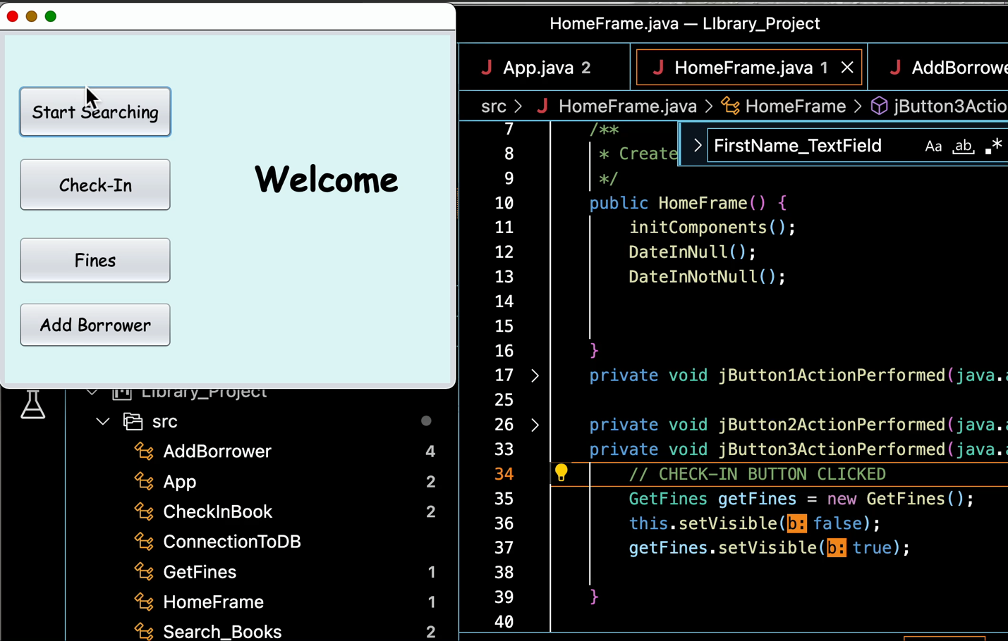**VIDEO GUIDE:**

**(DOUBLE CLICK ON BELOW VIDEO TO START)**